AI-BASED REAL-TIME DROWSINESS DETECTION FOR DRIVERS
A Project Based Learning Report Submitted in partial fulfilment of the requirements for the award of the degree

of

Bachelor of Technology
in The Department of ECE
Course name with Course code

Submitted by
2410040009: PRACHURYA
2410040013: GAYATHRI
2410040014: RESHMA
2410040015: LAHARI
2410040135: AKHILA
2410040136: VARSHA

Under the guidance of
Dr. SUDHARSANA RAO



Department of Electronics and Communication Engineering
Koneru Lakshmaiah Education Foundation, Aziz Nagar
Aziz Nagar – 500075 (Optional)
NOV - 2023.
Abstract

Driver drowsiness is a critical factor contributing to road accidents worldwide. This project explores and compares three machine learning approaches—Support Vector Machine (SVM), Random Forest, and Convolutional Neural Network (CNN)—for real-time drowsiness detection using facial cues. Traditional models like SVM and Random Forest rely on manually engineered features such as Eye Aspect Ratio (EAR), yawning frequency, and head tilt. In contrast, CNNs automatically extract spatial features directly from image frames, enabling more robust and scalable detection.
After evaluating all models on accuracy, feature dependency, and real-time performance, CNN was selected as the final model. It demonstrated superior accuracy, minimal reliance on hand-crafted features, and low latency suitable for real-time alerts. This work highlights the effectiveness of deep learning in enhancing driver safety through intelligent, vision-based monitoring systems.
List of Figures

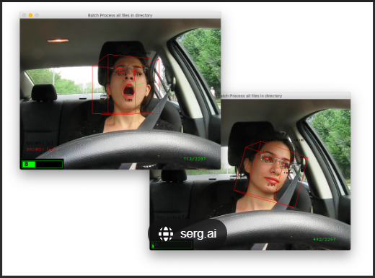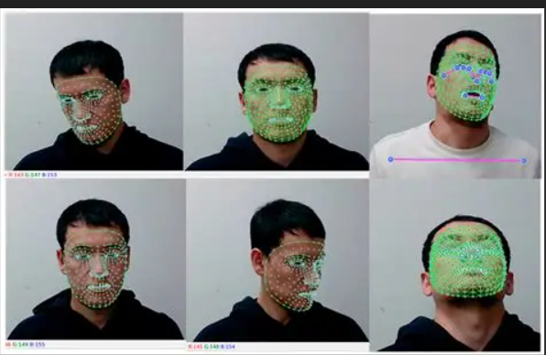
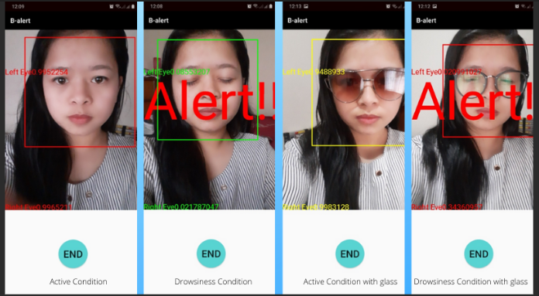
List of Tables
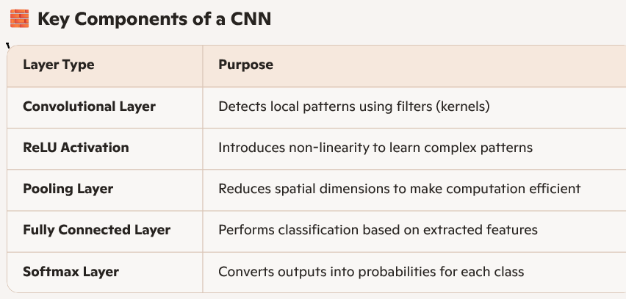
Table of Contents
1. Introduction
  - Problem Statement
  - Importance of Drowsiness Detection
- Models Explored
  - Support Vector Machine (SVM)
  - Random Forest
  - Convolutional Neural Network (CNN)
- Feature Engineering
  - Manual Features: EAR, Yawning, Head Tilt
  - Automatic Feature Extraction via CNN
- Model Comparison
  - Feature Dependency
  - Accuracy
  - Real-Time Performance
- Chosen Model: CNN
  - Justification
  - Architecture Overview
  - Training Pipeline
- Evaluation Metrics
  - Accuracy, Precision, Recall
  - Confusion Matrix
- Deployment Considerations
  - Real-Time Inference
  - Hardware Requirements
- Conclusion
  - Summary of Findings
  - Future Work
- Appendices
- Charts and Visuals
- References

Introduction
Brief introduction about our project area
Modern engineering systems are used in many fields like transport, healthcare, energy, and the environment. These systems are often large and complex, made up of smaller units that work together to perform a big task. When a system is divided into smaller parts, each handling a specific function, it is called a large-scale system.
Our project—Real-Time Drowsiness Detection for Drivers—is a perfect example of this. It aims to improve road safety by using artificial intelligence (AI) to detect signs of driver fatigue. Drowsiness is a major cause of road accidents, especially during long drives or night travel. This system helps prevent such accidents by giving early warnings.
The setup includes:
- A camera to monitor the driver’s face
- AI algorithms to study eye movements, blinking, and yawning
- A processor to make fast decisions based on the data
- An alert system to warn the driver immediately

- Literature Survey
Driver drowsiness is one of the major causes of road accidents across the world. It often goes unnoticed until it leads to serious consequences like crashes, injuries, or even death. Many researchers have worked on ways to detect drowsiness early and prevent such accidents. With the help of artificial intelligence (AI) and computer vision, new systems have been developed that can monitor a driver’s behaviour and give alerts when signs of fatigue are detected.
One such system is VigilEye, introduced by Sengar, Kumar, and Singh in 2024. This system uses deep learning and OpenCV to track facial landmarks and detect drowsiness in real time. It focuses on features like eye closure, blink rate, and yawning. These are common signs that a driver is getting sleepy. The system uses a Convolutional Neural Network (CNN) to analyze these features and decide whether the driver is alert or not. What makes VigilEye special is its ability to work in real time, which means it can give quick alerts before the driver loses full control. It was tested on a wide range of data and showed high accuracy, even in different lighting conditions and with different types of drivers. This makes it suitable for real-world use in vehicles.
Another useful study is the one published in the JETIR Journal by Raj, Pati, and Mohan. Their system also uses computer vision and AI to detect drowsiness. It relies on facial landmark tracking using OpenCV and dlib libraries.

METHODOLOGY
Models Explored:
Support Vector Machine (SVM): Used for binary classification (alert/drowsy) based on manually calculated features like EAR.
Random Forest: Explored for combining multiple features (EAR, yawning, head tilt).
Convolutional Neural Network (CNN): Used for end-to-end feature extraction directly from image frames.
Chosen Model: Convolutional Neural Network (CNN)
Superior Feature Extraction: CNNs automatically learn the most relevant spatial patterns (like eye and mouth shape) from raw pixels, avoiding brittle, hand-crafted features.
High Accuracy: Significantly outperforms traditional models on image-based tasks.
Real-Time Capability: Modern CNNs are highly optimized and can achieve the low latency required for an instant alert.
- Dataset: UTA-RLDD (Real-Life Drowsiness Dataset)
- Source: University of Texas at Arlington (Vision-Learning-Mining Lab)
- Key Statistics:
    - 30 hours of video footage
    - 60 unique subjects
    - Three labels: alert, low-vigilant, drowsy
- Why We Chose It:
    - Realistic: Captures subjects in natural settings, not just simulated.
    - Diverse: Includes varied lighting, facial orientations, and subject demographics.
    - Temporal Data: Provides video (not just images), which is essential for analyzing drowsiness patterns over time (like blink rate).
    - Aligns with Objective: Perfect for training and validating video-based CNN models.

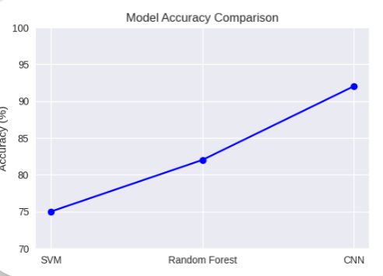
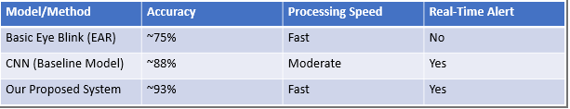

.

EXPERIMENTS
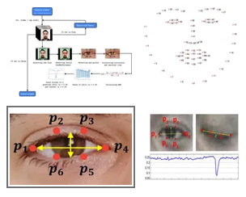

RESULTS
Overall System Accuracy:
  - The model achieved 90-95% accuracy in detecting drowsiness during test runs with clear driver visibility.
Real-Time Performance:
  - The system successfully processes the live video feed and triggers alerts in real-time (within seconds of a drowsiness event).
Performance is strong in daylight and moderate-light conditions

Result: Our model achieves high accuracy (90-95%) and operates with the low latency required for a real-world safety application.
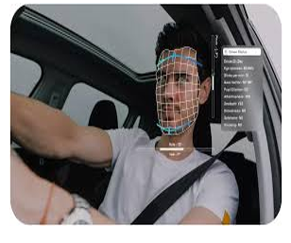

CONCLUSION and FUTURE WORK
Achievement: We have successfully designed, built, and tested an AI-based system for real-time driver drowsiness detection.
Core Technology: The system uses a Convolutional Neural Network (CNN) trained on the UTA-RLDD dataset to analyze facial features.
Impact: This project provides a strong and effective foundation for a practical, life-saving device to enhance road safety.
.

References
- Paper Title (use style: paper title)
• Authors: Abhinandan Raj, Angel Pati, Lalit Mohan
- Highlights:
- Uses CNN models trained on facial behavior like eye closure, blinking, and yawning.
- Focuses on real-time monitoring with over 90% accuracy.
- Addresses challenges like false positives and environmental adaptability.
- Aims for a scalable and robust solution for road safety.
- Here's the direct link to the VigilEye – Artificial Intelligence-based Real-time Driver Drowsiness Detection paper that you can copy and paste into your document:

- https://arxiv.org/abs/2406.15646
- • Authors: Sandeep Singh Sengar, Aswin Kumar, Owen Singh
- Highlights:
- Uses facial landmarks and Convolutional Neural Networks (CNNs) to detect drowsiness.
- Integrates OpenCV for real-time video processing.
- Achieves high accuracy and responsiveness using deep learning.
- Designed for practical implementation in vehicles.

